A CRM APPLICATION FOR THECHAISHOP&CO

Salesforce-Based Project Documentation Project Documentation
Prepared for Project Submission

Team Members Name : Asha.T,
Sagana.S,
Usha.S
Register Number : 24131281801022001,
24131281801022002,
24131281801022003.
Department : B.Sc. Artificial Intelligence
College Code : ANM128
Institution Name : Anandhan Memorial Arts and Science- Vanniyarpalayam.

Submitted To,

Naan Mudhalvan Program
Academic Year:2026–2027
College Code: ANM128
University : AnnamalaiUniversity

A CRM APPLICATION FOR THECHAISHOP&CO

Document Note

This document provides the main steps required for the CRM Application for The Chai Shop & Co using Salesforce. It covers customer and contact management, product and order management, pricing and order calculations, reports and dashboards, automation, validation, page layouts, user access and security. Only the necessary information and steps are included to make the document simple, clear and easy to understand.

Contents

1. Project Overview
2. Problem Statement
3. Objectives
4. Requirements and Technology
5. Project DesignPhase
6. Project Planning &Scheduling
7.Salesforce Setup
8.Standard and Custom Objects
9.Create a lightning app
10. Global Picklist
11. Fields & their relationships.
12.Page Layouts
13.Record Types
14.Validation Rules
15.Email Templates
16.Flows
17.Reports and Dashboards.
18. Functional &Performance Testing
19. Advantages and Disadvantages
20.Future Scope
21. Conclusion.

- Project Overview

The CRM Application for The Chai Shop & Co is a Salesforce-based application for managing customer accounts, contact information, products, orders, order products, sales calculations, reports, dashboards and customer communication in one place.
The system replaces scattered manual processes with a centralized cloud platform. Sales representatives can create and update customer records, maintain product and price information, create orders, record quantities and unit prices, review order amounts, and view sales reports.

Main Modules

Customer and Account Management
Contact Management
Product and Price Management
Order Management
Order Product Management
Sales and Total Bill Calculation
Reports and Dashboards
Customer Notification Automation
User Access and Security

2.Problem Statement

Sales and customer information can become difficult to manage when customer details, product prices, orders and billing information are maintained manually or in separate records. Manual calculations can also lead to incorrect order totals. Managers may not have a clear view of sales information.
The proposed CRM provides a centralized Salesforce solution to store customer and product data, manage orders, support sales calculations, control user access, automate selected activities and generate reports.

3.Objectives

Store customer and contact information in a centralized Salesforce system.
Maintain product details, product codes and prices.
Create and manage customer orders.
Record order product quantity and unit price.
Support accurate total order/bill amount calculation.
Reduce incorrect data using validation rules.
Automate selected customer and sales processes using Flow.
Provide role/profile-based access to project users.
Generate reports and dashboards for sales analysis.

4. Requirements and Technology

4.1 Customer Journey Map
Journey Stages:
- Login
- Access CRM Application
- Enter Customer Data
- Generate Orders
- Calculate Bills
- View Reports
- Decision Making

4.2 Solution Requirements
Functional Requirements
Non-Functional Requirements
The system should be easy to use for sales representatives, managers, administrators, and analysts without requiring technical training.
Requirements:
- Simple and intuitive user interface
- Clear navigation menus
- Easy-to-understand forms
- User-friendly dashboards
Example:
A new sales employee should be able to log in, enter customer details, and generate orders within a few minutes without help.
Salesforce Lightning UI provides drag-and-drop features and easy navigation.
Security
The system must protect customer and business data from unauthorized access.
Requirements:
- Role-based access control
- Secure login authentication
- Encrypted data storage
- Data backup and recovery
Examples:
- Profiles and permission sets
- Object-level and field-level security
- Restricted billing access
- Secure login and password policies
The CRM system should always work correctly and store data accurately without loss.
Requirements:
- Automatic data saving
- Regular system backups
- Error handling mechanisms
- Stable cloud environment
Example:
If a user enters order data and the internet disconnects, the system should save the information and restore it later.
Salesforce cloud ensures automatic backups.
Performance
The system should respond quickly and handle large amounts of data efficiently.
Requirements:
- Fast page loading
- Quick report generation
- Smooth dashboard rendering
Availability
The system should be accessible whenever required.
Requirements:
- 24/7 system availability
- Minimal downtime
- Cloud-based hosting
- Disaster recovery

Example: Managers should be able to access the CRM system during peak business hours, weekends, or late nights.
Salesforce cloud provides high uptime.

Scalability
The system should support business growth without affecting performance.
Requirements:
- Ability to handle more users
- Support increasing customer data
- Expandable storage
- Maintain system speed
Example: If TheChaiShop&Co expands to multiple branches, the CRM system should support thousands of customers without slowing down.
Salesforce infrastructure automatically scales.

4.3 Data Flow Diagram
User → Salesforce UI → Custom Objects → Validation Rules → Flows → Reports → Dashboards.
4.4 Technology Stack
Layer | Technology
Frontend | Salesforce Lightning
Database | Salesforce Cloud
Automation | Flows
Backend | Salesforce Platform
Analytics | Reports & Dashboards

5. PROJECT DESIGN PHASE

5.1 Problem–Solution Fit
The CRM system replaces manual records with automated data management. Cloud storage prevents data loss, dashboards improve analysis, and real-time reports eliminate delays. This ensures accurate and timely business insights generation.

5.2 Proposed Solution
Functional Requirements

Parameter | Description
User Login & Authentication | Allows authorized users to securely log in to the CRM system using valid credentials.
Customer Record Management | Enables users to create, view, update, and delete customer details such as name, contact number, and address.
Employer & Enterprise Management | Allows management of employer and enterprise account information for business operations.
Order Management | Supports creation and tracking of customer orders, including order quantity and product details.
Automated Billing System | Automatically calculates total bill amount using formula fields based on order quantity and pricing.
Validation Rules | Ensures accurate data entry by validating fields such as phone number, PAN, and Aadhaar.
Record Types & Page Layouts | Provides different record types and layouts for various customer and enterprise categories.
Global Picklists | Maintains standardized values for fields such as product type, category, and status.
Email Notification System | Sends automated emails to customers for birthdays, offers, and order confirmations.
Workflow & Flow Automation | Automates tasks such as updating records and triggering alerts using Salesforce Flows.
Report Generation | Generates detailed reports on sales, customers, and enterprise performance.
Dashboard Visualization | Displays real-time analytics through interactive dashboards and charts.
Data Backup & Recovery | Ensures secure storage and recovery of business data in the Salesforce cloud.
User Role Management | Controls system access using profiles and permission sets for different users.

5.3 Solution Architecture
Architecture Layers
- Presentation Layer – Lightning UI
- Application Layer – Flows and Logic
- Data Layer – Custom Objects
- Analytics Layer – Reports and Dashboards
This layered architecture ensures modularity, scalability, and maintainability.

6. PROJECT PLANNING & SCHEDULING

6.1 Project Planning
- The project followed an Agile-based development approach with defined milestones and sprints.
- A Salesforce Developer account was created to set up the development environment.
- Custom objects were designed to store customer, employer, and enterprise data.
- Custom tabs and a Lightning Application were developed for easy system navigation.
- Fields, relationships, and global picklists were configured to ensure data consistency.
- Page layouts and record types were created based on user roles and customer categories.
- Validation rules were implemented to prevent incorrect data entry.
- Email templates and automated flows were developed for customer notifications.
- Reports and dashboards were created for performance monitoring and analysis.
- Regular sprint reviews and testing were conducted to track progress and resolve issues.
- The project was completed within the planned timeline through systematic scheduling.

7.Salesforce Setup

Step 1: Create Salesforce Developer Account

Open the Salesforce Developer signup page.
Enter name, email, job title, college/company and country.
Submit the signup form.
Open the verification email and activate the account.
Set the password and security information.
Open the Salesforce Setup page.

Step 2: Open Setup

Log in to Salesforce.
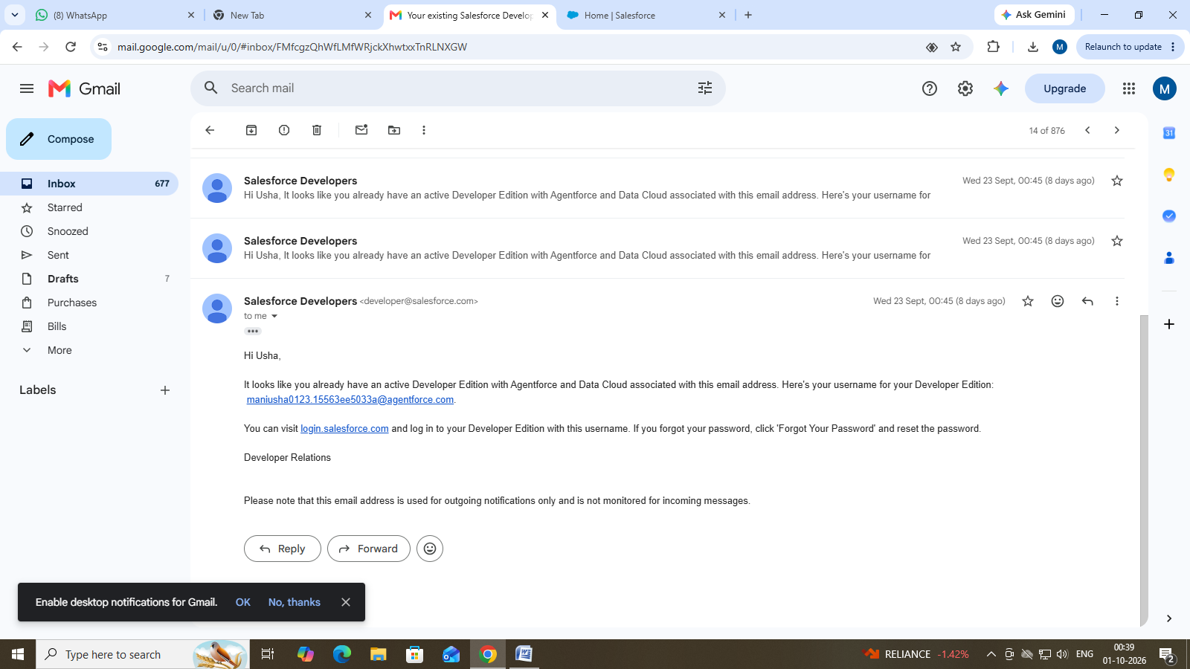

1.Click gear icon on the top left and select Setup to open Setup.

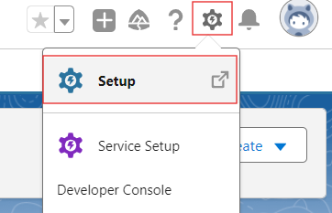

2.Click the Object Manager tab. If you don’t see it, enter Object Manager in the Quick Find box.
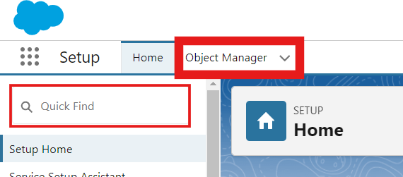

3.On the Object Manager page, click Create | Custom Object.

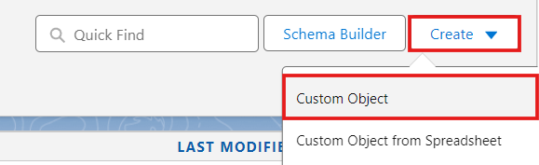

8.Standard and Custom Objects

The CRM project can be implemented mainly with Salesforce standard objects such as Account, Contact, Product, Price Book, Order and Order Product. Custom objects may be added if the project requires extra business-specific data.
Object
Record/Data Purpose

Account
Customer or business account

Contact
Customer contact person

Product
Chai/product details

Price Book
Product selling price

Order
Customer order

Order Product
Quantity and unit price for each ordered product

Common Steps to Configure an Object
Go to Setup → Object Manager.
Select the required object.
Open Fields & Relationships or relevant settings.
Create or edit the required fields.
Save the configuration.
Verify the fields on the page layout.

9.Custom tabs creation

- Go to setup page → type Tabs in Quick Find bar → click on tabs → New (under custom object tab)

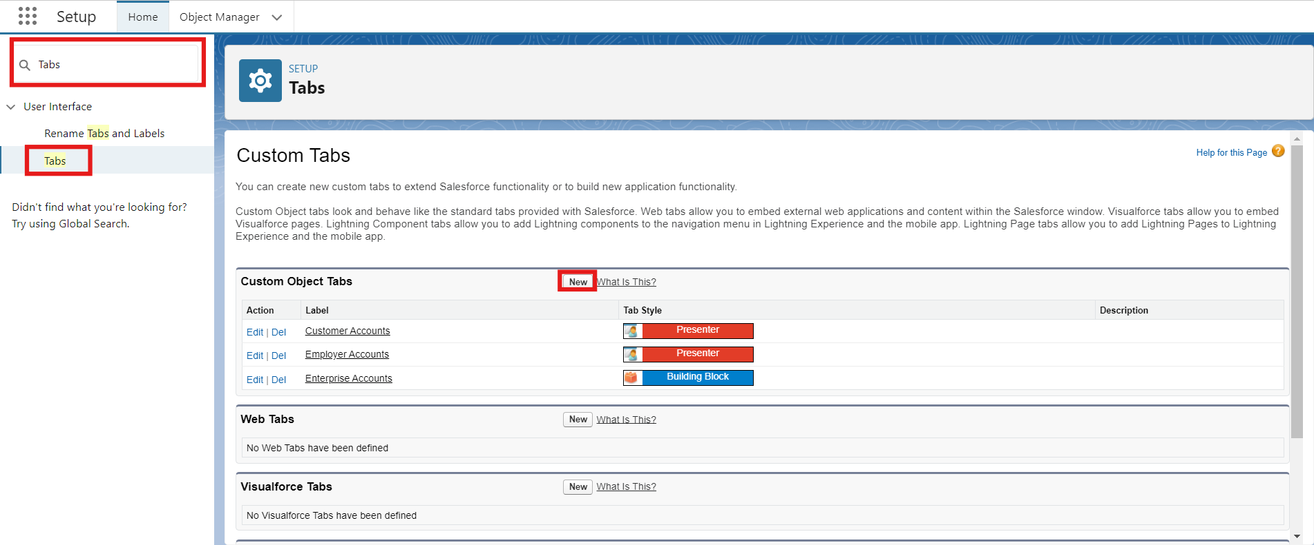

- Select Object(Employer Accounts) → Select the tab style → Next (Add to profiles page) keep it as default → Next (Add to Custom App) uncheck the include tab .
- Make sure that the Append tab to users' existing personal customizations is checked.
- Click save.
- Repeat the same steps for Customer Accounts and Enterprise Accounts.

10.Create a lightning app

- Go to setup page → search “app manager” in quick find → select “app manager” → click on New lightning App.

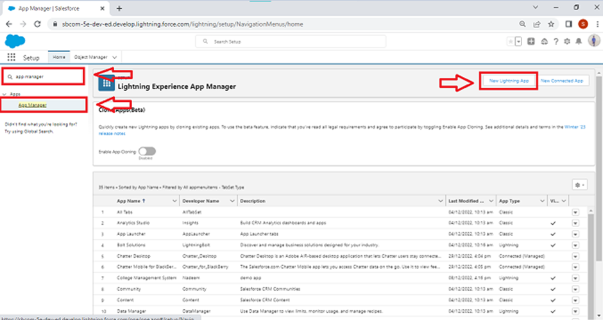

- Fill the app name in app details and branding as follow
App Name : TheChaiShop&Co
Developer Name : Auto Populates
Add image optional (if you want to give any image you can otherwise not mandatory) - Add Primary color Hex or leave it to default.
Then click Next.

- In App options
Navigation style : Standard navigation
Setup experience : setup
Supporters form factors : Desktop and phone
Then click Next

- In Utility items
Utility Bar alignment : Default
Then click Next.

- Navigation items
Select the created Custom Objects and required standard objects
- Customer Accounts
Employer Accounts
Enterprise Accounts
Reports
Dashboards.
- To Add User Profiles : System Administrator
- Click Save & Finish.
11.Global Picklist

Create Global Picklist

- In Quick find box search for : Picklist value sets and click New.

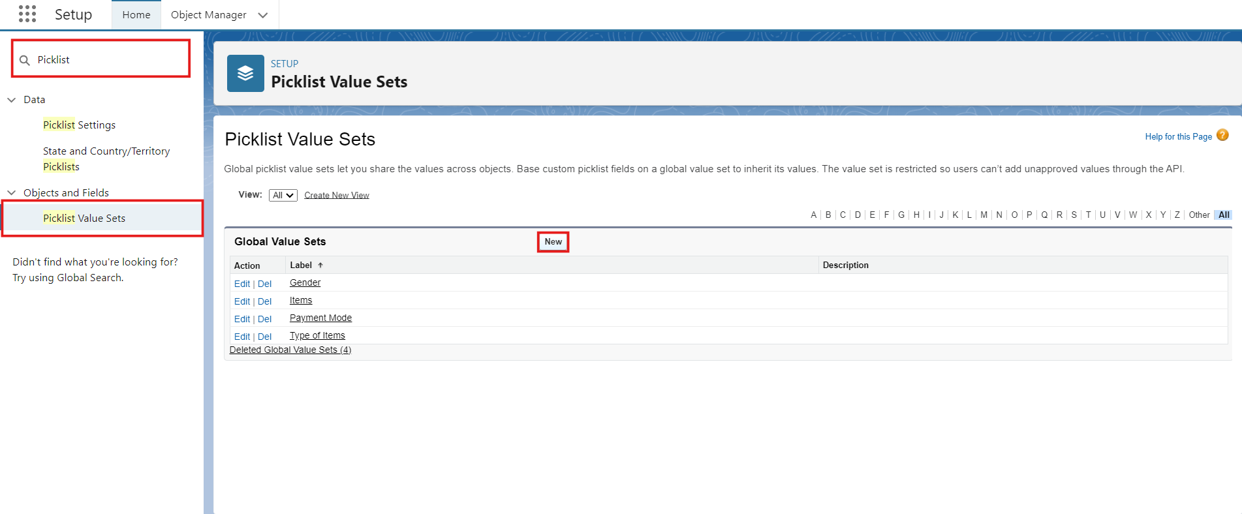

- Label : Gender
Name : Auto Populates
Values : Male
Female
Others
Click Save & New.

- Create three more Global picklists following the same steps.
- Label : Items
Name : Auto populates
Values : Platinum Tea Powder
Double Delight Tea Powder
Super Dust Tea Powder
Osmania Biscuits (Value Pack)
Osmania Biscuits (Premium Pack)
Dry Fruit Biscuits
Fruit Biscuits
Salt Biscuits
Multigrain Biscuits
Ragi Biscuits
Double Choco Chip Cookies
Butter Almond Cookies
Melting Moments Cookies
Honey Oats Cookies
Delight Box
Signature Box
Assorted Box
Click Save & New.

- Label : Payment Mode
Name : Auto populates
Values : Gpay
PhonePe
Paytm
Credit or Debit card
Cash.
Click Save & New.

- Label : Type of Items
Name : Auto populates
Values : Tea powder
Cookies
Gift Hampers
Click Save.

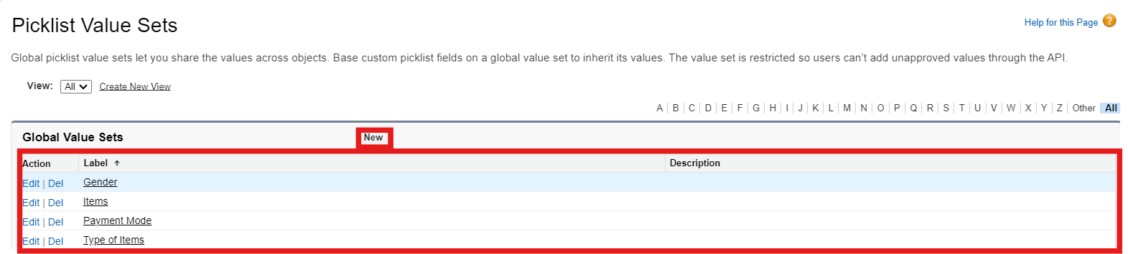

12. Fields & Relationships

Activity 1 : Create Custom fields for Employer Account

- In your Salesforce org, click gear icon on the top left and select Setup to open Setup.
- Click the Object Manager tab. If you don’t see it, enter Object Manager in the Quick Find box.
- From the object manager page, In the Quick Find box, Search for the custom object you just created : Employer Account
- From the sidebar, click Fields & Relationships. Notice that there are already some fields there. Those are the standard fields.
- Click New to create a custom field. Tip: Before creating a new field, do a quick search to make sure a similar one doesn’t already exist.

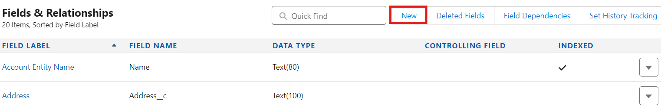

- Next, choose a data type as Text. Choosing a data type helps you format the field input.

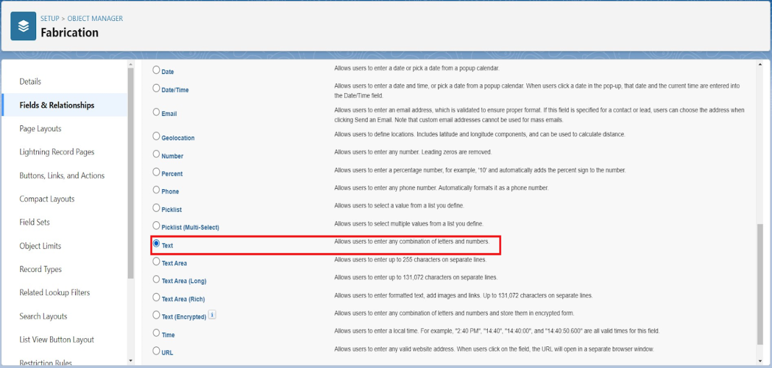

- Click on next.
- Data Type : Text
Field Label: First Name
Field Name : Auto Populates
Length : 25
Required : Check the box
Click on Next → Next → Save and new.

- Repeat the Same steps for remaining fields

- Data Type : Text
Field Label: Last Name
Field Name : Auto Populates
Length : 25
Required : Check the box
Click on Next → Next → Save and new.

- Data Type : PickList
Field Label: Gender
Values : Use Global Picklist value set and
select Gender from the dropdown menu.
Field Name : Auto Populates.
Required : Check the box
Click on Next → Next → Save and new.

- Data Type : Phone
Field Label : Phone Number
Field Name : Auto Populates
Required : Check the box
Click on Next → Next → Save and new.

- Data Type : Email
Field Label : Email ID
Field Name : Auto Populates
Required : Check the box
Click on Next → Next → Save and new.

- Data Type : Date
Field Label : Date of Birth
Field Name : Auto Populates
Required : check the box
Click on Next → Next → Save and new.

- Data Type : Text
Field Label : Aadhar Number
Field Name : Auto Populates
Length : 12
Click on Next → Next → Save and new.

- Data Type : Text
Field Label : PAN Details
Field Name : PAN_Details
Length : 10
Click on Next → Next → Save and new.

- Data Type : Picklist
Field Label : Designation
Field Name : Auto Populates
Value : Enter value, with each value separated by a new line.
Manager
Finance and Accounting
Kitchen Staff
Cashier
Servers
Click on Next → Next → Save and new.

- Data Type : Currency
Field Label : Salary
Field Name : Auto Populates
Click on Next → Next → Save.

Activity 2: Create Custom fields for Customer Account

- Data Type : Text
Field Label: First Name
Field Name : Auto Populates
Length : 25
Required : Check the box
Click on Next → Next → Save and new.

- Data Type : Text
Field Label: Last Name
Field Name : Auto Populates
Length : 25
Required : Check the box
Click on Next → Next → Save and new.

- Data Type : PickList
Field Label: Gender
Values : Use Global Picklist value set and
select Gender from the dropdown menu.
Field Name : Auto Populates.
Required : Check the box
Click on Next → Next → Save and new.

- Data Type : Phone
Field Label : Phone Number
Field Name : Auto Populates
Required : Check the box
Click on Next → Next → Save and new.

- Data Type : Date
Field Label : Date of Birth
Field Name : Auto Populates
Required : check the box
Click on Next → Next → Save and new.

- Data Type : Formula
Field Label : Date of Birthday is today ?
Field Name : Auto Populates
Formula Return : Checkbox
Formula :
IF(
AND(
DAY( TODAY() ) = DAY( Date_of_Birth__c ) ,
MONTH ( TODAY()) = MONTH( Date_of_Birth__c )),
TRUE,
FALSE)
Click on Next → Next → Save and new.

- Data Type : Email
Field Label : Email ID
Field Name : Auto Populates
Required : Check the box
Click on Next → Next → Save and new.

- Date Type : Text
Field Label : Address
Field Name : Auto Populates
Length : 125
Click on Next → Next → Save and new.

- Date Type : Multi Select Picklist
Field Label : Type of Items
Values : Use Global Picklist value set and
select Type of Items from the dropdown menu.
Field Name : Auto Populates.
Required : Check the box
Click on Next → Next → Save and new.

- Date Type : Multi Select Picklist
Field Label : Products purchased
Values : Use Global Picklist value set and
select Items from the dropdown menu.
Field Name : Auto Populates.
Required : Check the box
Click on Next → Next → Save and new.

- Date Type : Multi Select Picklist
Field Label : Chai
Value : Enter value, with each value separated by a new line.
TheChaiShop&Co Special Tea
Single Tea
Masala Tea
Lemon Tea
Ginger Tea
Green Tea
Sugar Free Tea
Click on Next → Next → Save and new.

- Data Type : Picklist
Field Label : Payment Mode
Values : Use Global Picklist value set and
select Payment Mode from the dropdown menu.
Field Name : Auto Populates.
Required : Check the box
Click on Next → Next → Save and new.

- Data Type : Lookup Relationship
Related To : Employer Account
Field Label : Associated Employer
Field Name : Auto Populates
Click on Next → Next → Save and new.

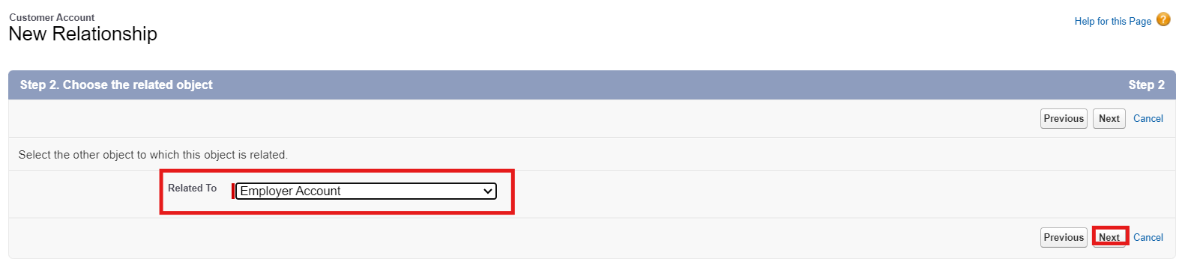

- Data Type : Formula
Field Label : Order Quantity
Field Name : Auto Populates
Formula Return : Number

Enter Formula = Quantity (Number) =
IF(INCLUDES( Products_Purchased__c , "Platinum Tea Powder"), 1, 0 ) +
IF(INCLUDES( Products_Purchased__c , "Double Delight Tea Powder"), 1, 0 ) +
IF( INCLUDES( Products_Purchased__c , "Super Dust Tea Powder") , 1, 0) +
IF(INCLUDES( Products_Purchased__c , "Osmania Biscuits (Value Pack)"), 1, 0 ) +
IF(INCLUDES( Products_Purchased__c , "Osmania Biscuits (Premium Pack)"), 1, 0 ) +
IF( INCLUDES( Products_Purchased__c , "Dry Fruit Biscuits") , 1, 0) +
IF(INCLUDES( Products_Purchased__c , "Fruit Biscuits"), 1, 0 ) +
IF(INCLUDES( Products_Purchased__c , "Salt Biscuits"), 1, 0 ) +
IF(INCLUDES( Products_Purchased__c , "Multigrain Biscuits"), 1, 0 ) +
IF(INCLUDES( Products_Purchased__c , "Ragi Biscuits"), 1, 0 ) +
IF( INCLUDES( Products_Purchased__c ,"Double Choco chip Cookies") , 1, 0) +
IF(INCLUDES( Products_Purchased__c , "Butter Almond Cookies"), 1, 0 ) +
IF(INCLUDES( Products_Purchased__c , "Melting Moments Cookies"), 1, 0 ) +
IF( INCLUDES( Products_Purchased__c , "Honey Oats Cookies") , 1, 0) +
IF(INCLUDES( Products_Purchased__c , "Delight Box"), 1, 0 ) +
IF(INCLUDES( Products_Purchased__c , "Signature Box"), 1, 0 ) +
IF( INCLUDES( Products_Purchased__c , "Assorted Pack") , 1, 0) +
IF(INCLUDES( Chai__c , "TheChaiShop&Co Special Tea"), 1, 0) +
IF(INCLUDES( Chai__c , "Single Tea"), 1, 0) +
IF(INCLUDES( Chai__c , "Masala Tea"), 1, 0) +
IF(INCLUDES( Chai__c , "Lemon Tea"), 1, 0) +
IF(INCLUDES( Chai__c , "Ginger Tea"), 1, 0) +
IF(INCLUDES( Chai__c , "Green Tea"), 1, 0) +
IF(INCLUDES( Chai__c , "Sugar Free Tea"), 1, 0)

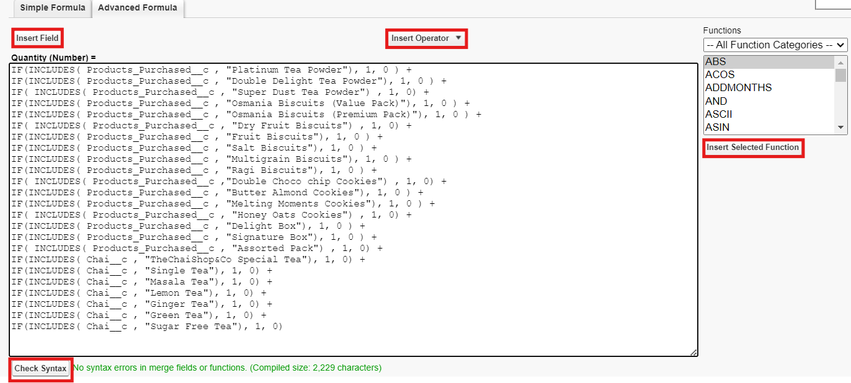
Click on Next → Next → Save and new.

- Data Type : Formula
Field Label : Total Bill
Field Name : Auto Populates
Formula Return : Number
Enter Formula = Quantity (Number) =
IF(INCLUDES( Products_Purchased__c , "Platinum Tea Powder"), 175, 0 ) +
IF(INCLUDES( Products_Purchased__c , "Double Delight Tea Powder"), 150, 0 ) +
IF( INCLUDES( Products_Purchased__c , "Super Dust Tea Powder") , 125, 0) +
IF(INCLUDES( Products_Purchased__c , "Osmania Biscuits (Value Pack)"), 50, 0 ) +
IF(INCLUDES( Products_Purchased__c , "Osmania Biscuits (Premium Pack)"), 80, 0 ) +
IF( INCLUDES( Products_Purchased__c , "Dry Fruit Biscuits") , 110, 0) +
IF(INCLUDES( Products_Purchased__c , "Fruit Biscuits"), 160, 0 ) +
IF(INCLUDES( Products_Purchased__c , "Salt Biscuits"), 110, 0 ) +
IF(INCLUDES( Products_Purchased__c , "Multigrain Biscuits"), 170, 0 ) +
IF(INCLUDES( Products_Purchased__c , "Ragi Biscuits"), 190, 0 ) +
IF( INCLUDES( Products_Purchased__c ,"Double Choco chip Cookies") , 200, 0) +
IF(INCLUDES( Products_Purchased__c , "Butter Almond Cookies"), 110, 0 ) +
IF(INCLUDES( Products_Purchased__c , "Melting Moments Cookies"), 150, 0 ) +
IF( INCLUDES( Products_Purchased__c , "Honey Oats Cookies") , 160, 0) +
IF(INCLUDES( Products_Purchased__c , "Delight Box"), 850, 0 ) +
IF(INCLUDES( Products_Purchased__c , "Signature Box"), 1500, 0 ) +
IF( INCLUDES( Products_Purchased__c , "Assorted Pack") , 600, 0) +
IF(INCLUDES( Chai__c , "TheChaiShop&Co Special Tea"), 70, 0) +
IF(INCLUDES( Chai__c , "Single Tea"), 50, 0) +
IF(INCLUDES( Chai__c , "Masala Tea"), 60, 0) +
IF(INCLUDES( Chai__c , "Lemon Tea"), 40, 0) +
IF(INCLUDES( Chai__c , "Ginger Tea"),55, 0) +
IF(INCLUDES( Chai__c , "Green Tea"), 45, 0) +
IF(INCLUDES( Chai__c , "Sugar Free Tea"), 55, 0)

Click on Next → Next → Save.

Activity 3: Create Custom fields for Enterprise Account

- Data Type : Text
Field Label: Enterprise Name
Field Name : Auto Populates
Length : 25
Required : Check the box
Click on Next → Next → Save and new.

- Data Type : Phone
Field Label : Phone Number
Field Name : Auto Populates
Required : Check the box
Click on Next → Next → Save and new.

- Data Type : Email
Field Label : Email ID
Field Name : Auto Populates
Required : Check the box
Click on Next → Next → Save and new.

- Date Type : Text
Field Label : Address
Field Name : Auto Populates
Length : 125
Click on Next → Next → Save and new.

- Date Type : Multi Select Picklist
Field Label : Type of Items
Values : Use Global Picklist value set and
select Type of Items from the dropdown menu.
Field Name : Auto Populates.
Required : Check the box
Click on Next → Next → Save and new.

- Date Type : Multi Select Picklist
Field Label : Products purchased
Values : Use Global Picklist value set and
select Items from the dropdown menu.
Field Name : Auto Populates.
Required : Check the box
Click on Next → Next → Save and new.

- Data Type : Lookup Relationship
Related To : Employer Account
Field Label : Associated Employer
Field Name : Auto Populates
Click on Next → Next → Save and new.

- Data Type : Formula
Field Label : Order Quantity
Field Name : Auto Populates
Formula Return : Number
Enter Formula = Quantity (Number) =
IF(INCLUDES( Products_Purchased__c , "Platinum Tea Powder"), 1, 0 ) +
IF(INCLUDES( Products_Purchased__c , "Double Delight Tea Powder"), 1, 0 ) +
IF( INCLUDES( Products_Purchased__c , "Super Dust Tea Powder") , 1, 0) +
IF(INCLUDES( Products_Purchased__c , "Osmania Biscuits (Value Pack)"), 1, 0 ) +
IF(INCLUDES( Products_Purchased__c , "Osmania Biscuits (Premium Pack)"), 1, 0 ) +
IF( INCLUDES( Products_Purchased__c , "Dry Fruit Biscuits") , 1, 0) +
IF(INCLUDES( Products_Purchased__c , "Fruit Biscuits"), 1, 0 ) +
IF(INCLUDES( Products_Purchased__c , "Salt Biscuits"), 1, 0 ) +
IF(INCLUDES( Products_Purchased__c , "Multigrain Biscuits"), 1, 0 ) +
IF(INCLUDES( Products_Purchased__c , "Ragi Biscuits"), 1, 0 ) +
IF( INCLUDES( Products_Purchased__c ,"Double Choco chip Cookies") , 1, 0) +
IF(INCLUDES( Products_Purchased__c , "Butter Almond Cookies"), 1, 0 ) +
IF(INCLUDES( Products_Purchased__c , "Melting Moments Cookies"), 1, 0 ) +
IF( INCLUDES( Products_Purchased__c , "Honey Oats Cookies") , 1, 0) +
IF(INCLUDES( Products_Purchased__c , "Delight Box"), 1, 0 ) +
IF(INCLUDES( Products_Purchased__c , "Signature Box"), 1, 0 ) +
IF( INCLUDES( Products_Purchased__c , "Assorted Pack") , 1, 0)
Click on Next → Next → Save and new.

- Data Type : Formula
Field Label : Total Bill
Field Name : Auto Populates
Formula Return : Number
Enter Formula = Quantity (Number) =
IF(INCLUDES( Products_Purchased__c , "Platinum Tea Powder"), 175, 0 ) +
IF(INCLUDES( Products_Purchased__c , "Double Delight Tea Powder"), 150, 0 ) +
IF( INCLUDES( Products_Purchased__c , "Super Dust Tea Powder") , 125, 0) +
IF(INCLUDES( Products_Purchased__c , "Osmania Biscuits (Value Pack)"), 50, 0 ) +
IF(INCLUDES( Products_Purchased__c , "Osmania Biscuits (Premium Pack)"), 80, 0 ) +
IF( INCLUDES( Products_Purchased__c , "Dry Fruit Biscuits") , 110, 0) +
IF(INCLUDES( Products_Purchased__c , "Fruit Biscuits"), 160, 0 ) +
IF(INCLUDES( Products_Purchased__c , "Salt Biscuits"), 110, 0 ) +
IF(INCLUDES( Products_Purchased__c , "Multigrain Biscuits"), 170, 0 ) +
IF(INCLUDES( Products_Purchased__c , "Ragi Biscuits"), 190, 0 ) +
IF( INCLUDES( Products_Purchased__c ,"Double Choco chip Cookies") , 200, 0) +
IF(INCLUDES( Products_Purchased__c , "Butter Almond Cookies"), 110, 0 ) +
IF(INCLUDES( Products_Purchased__c , "Melting Moments Cookies"), 150, 0 ) +
IF( INCLUDES( Products_Purchased__c , "Honey Oats Cookies") , 160, 0) +
IF(INCLUDES( Products_Purchased__c , "Delight Box"), 850, 0 ) +
IF(INCLUDES( Products_Purchased__c , "Signature Box"), 1500, 0 ) +
IF( INCLUDES( Products_Purchased__c , "Assorted Pack") , 600, 0)

- Data Type : Picklist
Field Label : Payment Mode
Values : Use Global Picklist value set and
select Payment Mode from the dropdown menu.
Field Name : Auto Populates.
Required : Check the box
Click on Next → Next → Save.

13.Page Layouts
For the personalized field view in Customer Accounts, let's create two page layouts
Online orders and Walk-In or

12.1Online Orders page layout

- Go to the setup page → click on object manager → From drop down click edit for Customer Account object.

- Click on the Page Layouts → click New.
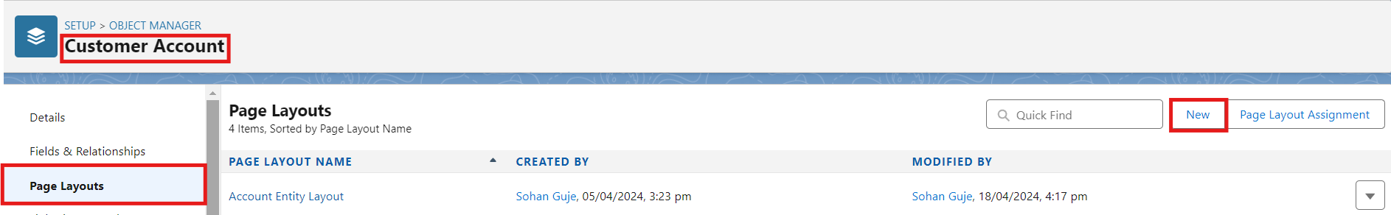

- Page Layout Name : Online Orders and click Save.

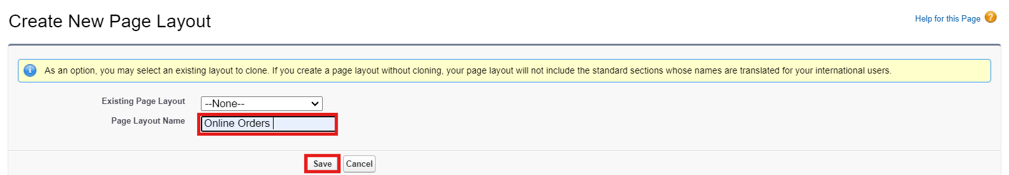

- Drag and arrange all the required fields as shown below.

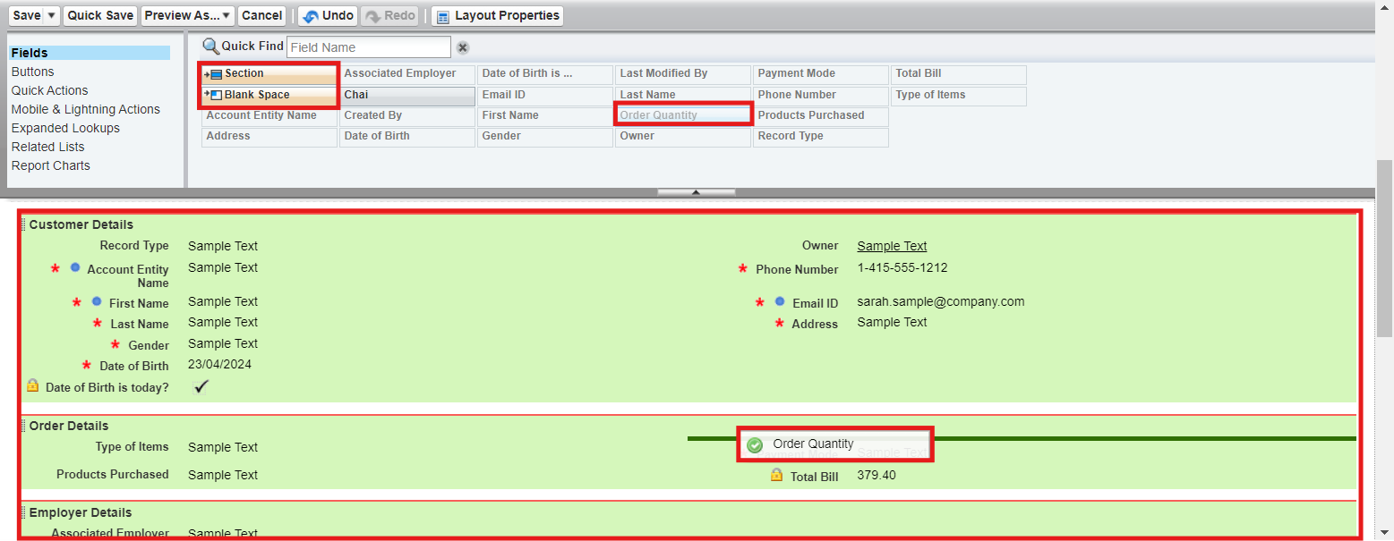

- Click Save.

12.2. Walk-In Orders page layout

- Go to the setup page → click on object manager → From drop down click edit for Customer Account object.

- Click on the Page Layouts → click New.

- Page Layout Name : Walk-In orders and click save.

- Drag and Arrange all the required fields as shown below.

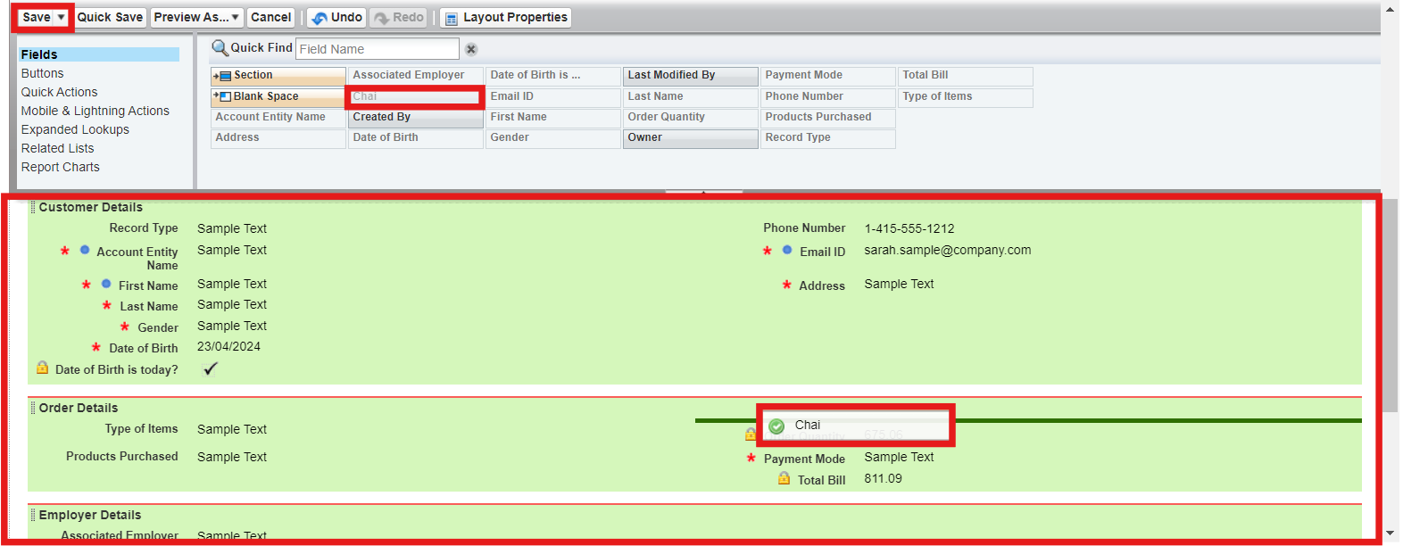

- Click Save.
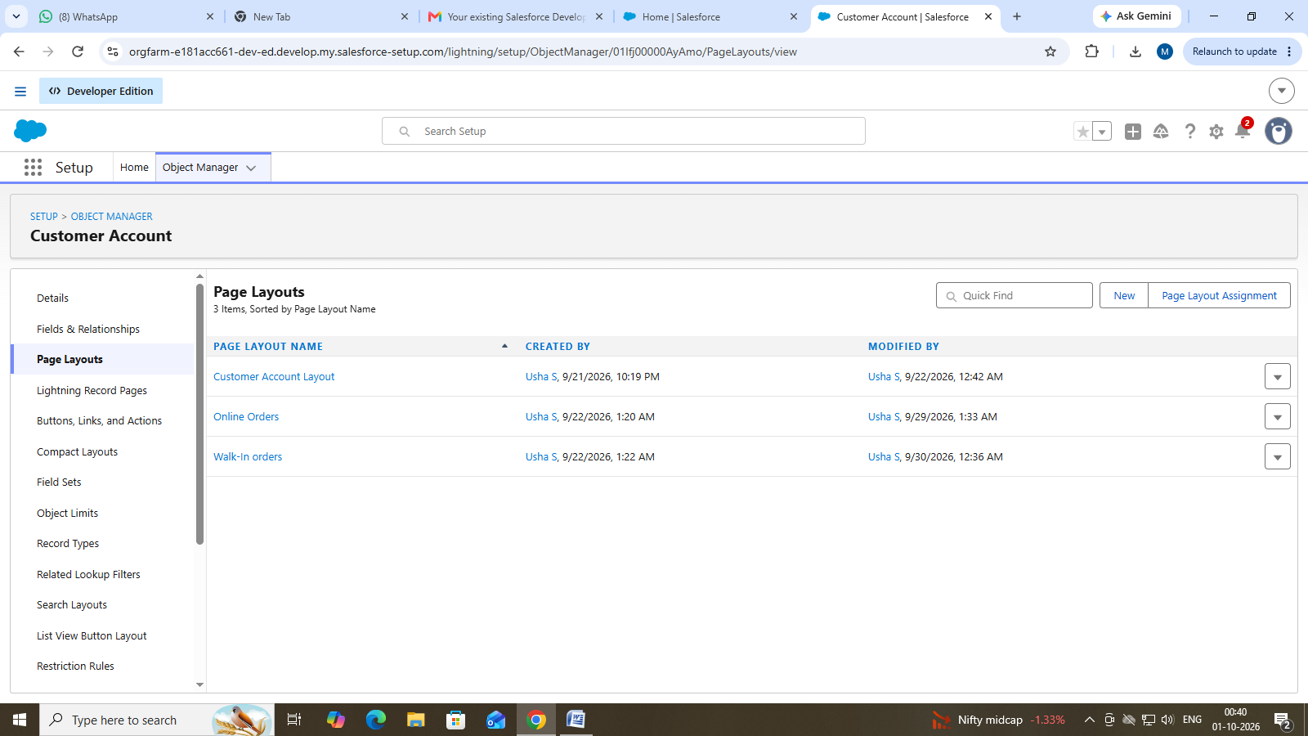

13.Record Types
To Differentiate the records and data stored in Customer Accounts, let's create two different Record Types.
Online orders and Walk-In orders.

13.1 Online Orders Record Type

- Go to the setup page → click on object manager → From drop down click edit for Customer Account object.

- Click on the Record Types → click New.

- Enter Details :
Existing Record Type : Master
Record Type Label : Online Order
Record Type Name : Auto Populates
Active : Tick the checkbox
Click Next

- In Assign Page Layouts
- Select Apply one layout to all profiles : select Online orders from the drop down menu.
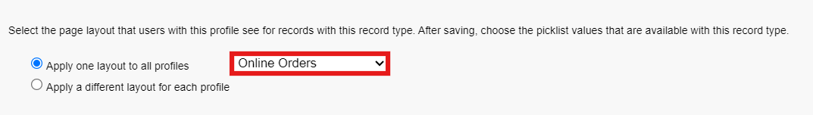

- Click Save and New.

13.2 Walk-In Orders Record Type

- Go to the setup page → click on object manager → From drop down click edit for Customer Account object.

- Click on the Record Types → click New.

- Enter Details :
Existing Record Type : Master
Record Type Label : Walk-In Order
Record Type Name : Auto Populates
Active : Tick the checkbox
Click Next

- In Assign Page Layouts
- Select Apply one layout to all profiles : select Walk-In orders from the drop down menu.

- Click Save.

15.Validation Rules

Activity 1: On Employer Account

- Go to the setup page → click on object manager → From drop down click edit for Employer Account object.

- Click on the validation rule → click New.
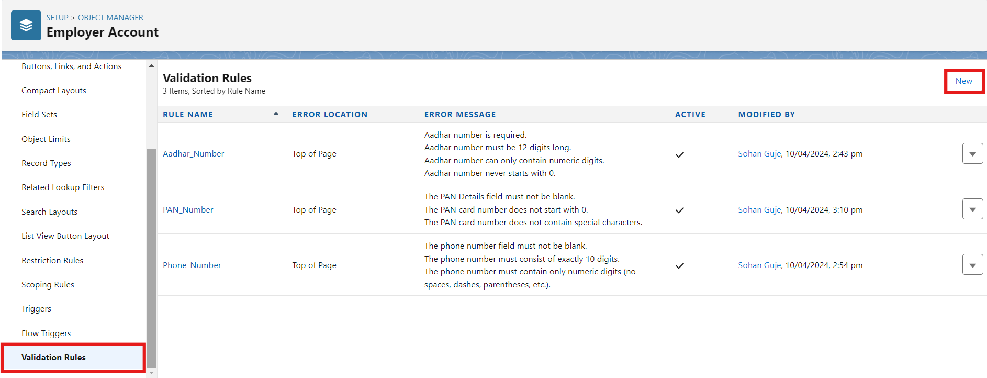

- Enter Rule Name : Aadhar Number
Error Condition Formula :
AND(
NOT(ISBLANK( Aadhar_Number__c )),
LEN( Aadhar_Number__c ) <> 12,
NOT(REGEX( Aadhar_Number__c , "^[1-9]{12}$"))
)

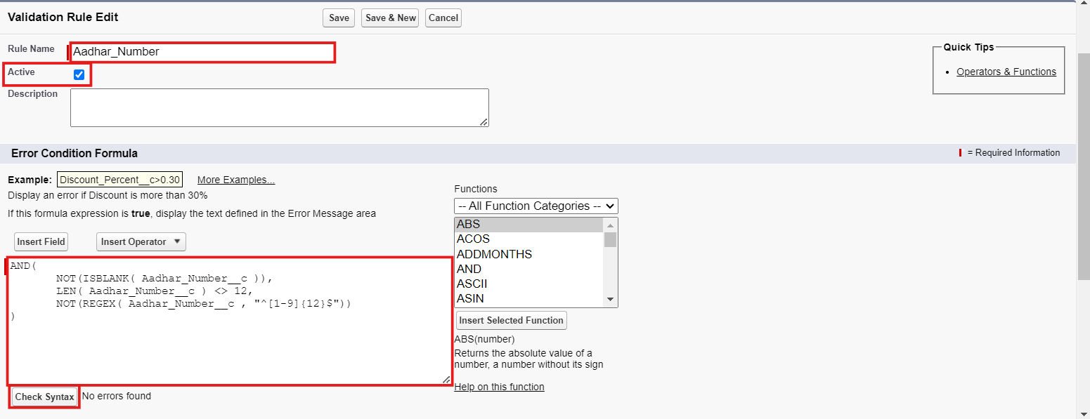

- Error Message : Aadhar number is required.
The Aadhar number must be 12 digits long.
Aadhar number can only contain numeric digits.
Aadhar number never starts with 0

- Click Save & New.

- Repeat the same steps and create two more validation rules on the employer account object.

- Enter Rule Name : PAN Number
Error Condition Formula :
AND(
NOT(ISBLANK( Phone_Number__c )),
NOT(REGEX( Phone_Number__c , "^[1-9]{10}$")),
NOT(REGEX( Phone_Number__c , "^\\d+$"))
)

Error Message : The PAN Details field must not be blank.
The PAN card number does not start with 0.
The PAN card number does not contain special characters.

Click Save & New.

- Enter Rule Name : Phone Number
Error Condition Formula :
AND(
NOT(ISBLANK( Phone_Number__c )),
NOT(REGEX( Phone_Number__c , "^[1-9]{10}$")),
NOT(REGEX( Phone_Number__c , "^\\d+$"))
)

Error Message :
The phone number field must not be blank.
The phone number must consist of exactly 10 digits.
The phone number must contain only numeric digits
(no spaces, dashes, parentheses, etc.)

Click Save.

Activity 2: On Customer Account

- Go to the setup page → click on object manager → From drop down click edit for Customer Account object.

- Click on the validation rule → click New.

- Enter Rule Name : Phone Number

Error Condition Formula :
AND(
NOT(ISBLANK( Phone_Number__c )),
NOT(REGEX( Phone_Number__c , "^[1-9]{10}$")),
NOT(REGEX( Phone_Number__c , "^\\d+$"))
)

Error Message :
The phone number field must not be blank.
The phone number must consist of exactly 10 digits.
The phone number must contain only numeric digits
(no spaces, dashes, parentheses, etc.)

- Click Save.

Activity 3: On Enterprise Account

- Go to the setup page → click on object manager → From drop down click edit for Customer Account object.

- Click on the validation rule → click New.

- Enter Rule Name : Phone Number

Error Condition Formula :
AND(
NOT(ISBLANK( Phone_Number__c )),
NOT(REGEX( Phone_Number__c , "^[1-9]{10}$")),
NOT(REGEX( Phone_Number__c , "^\\d+$"))
)

Error Message :
The phone number field must not be blank.
The phone number must consist of exactly 10 digits.
The phone number must contain only numeric digits
(no spaces, dashes, parentheses, etc.)

- Click Save.
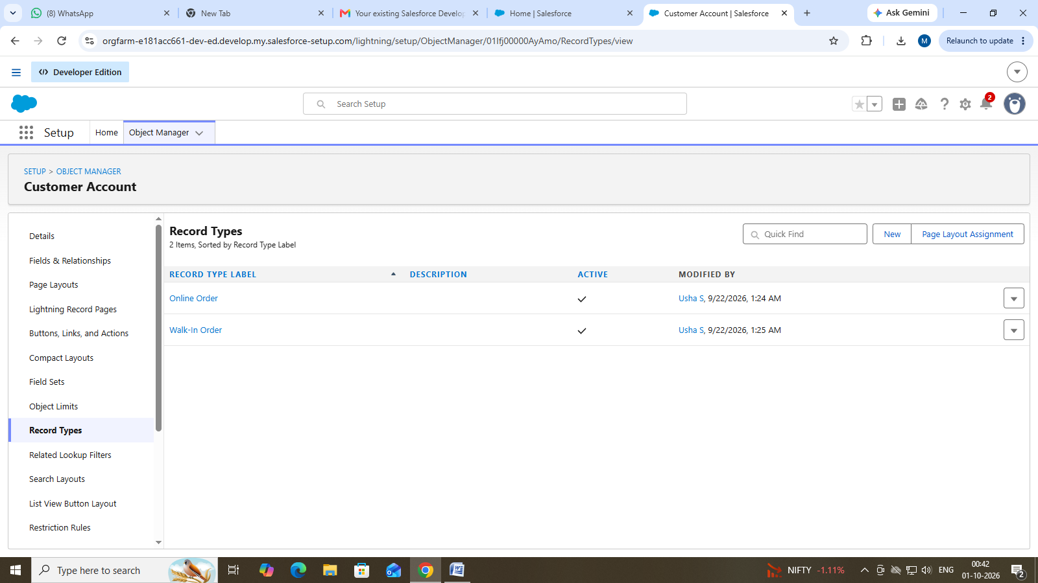

16.Email Template

Activity 1: Email Template

- Go to setup, In quick find box enter Email template → click on classic Email Template.

- Click on→ New Email Template

- Choose the type of email template you would like to create : Text and click Next.

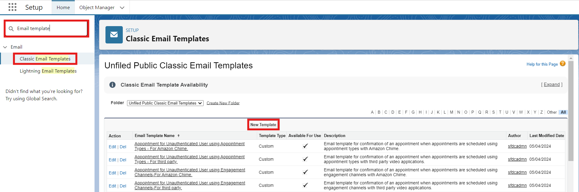

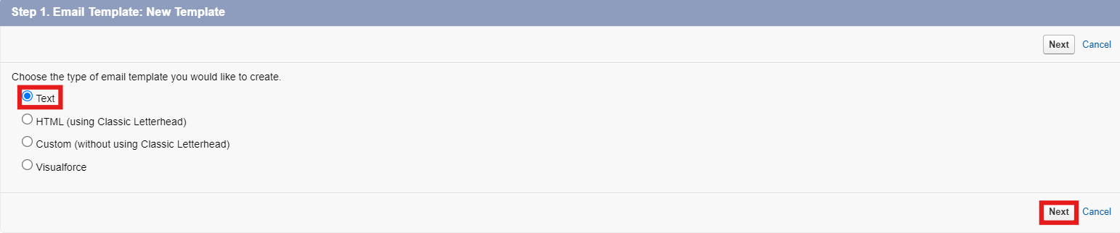

- Available Merge Fields
Select Field Type : Customer Accounts Fields
Select Field : First Name
Copy Merge Field value : Auto Populates, Copy the value and paste it in the email body where required.

- Folder : Unfiled public Classic Email templates
- Click on available for use
- Email Template Name is “Birthday Offer Email”
- Template Unique Name : Auto populated
- Subject : Special Birthday Offer Inside!
- Email body :
Dear {!Customer_Account__c.First_Name__c},

Happy Birthday from all of us at TheChaiShop&Co! 🎉🎂 We hope your special day is filled with joy, laughter, and wonderful memories.

To celebrate your birthday, we have a special gift just for you! As a token of our appreciation for your continued support, we're delighted to offer you an exclusive birthday discount.

🎁 Birthday Offer: Enjoy a fantastic 50% off on your next purchase as our birthday gift to you!

This offer is our way of saying thank you for being a valued customer. Simply use the code [HBDAY50] at checkout to redeem your birthday treat.

We hope this special offer adds a little extra sparkle to your birthday celebrations!

Once again, happy birthday! Thank you for choosing TheChaiShop&Co! and being part of our community.

Warm regards
TheChaiShop&Co!

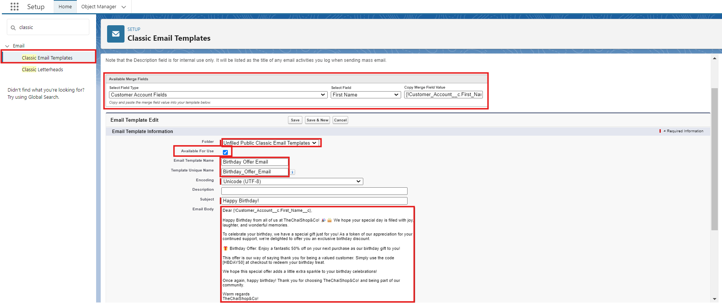

- Click Save.

Activity 2: Email Alert

- Go to setup, In quick find box enter Email Alert → click on Email Alert .

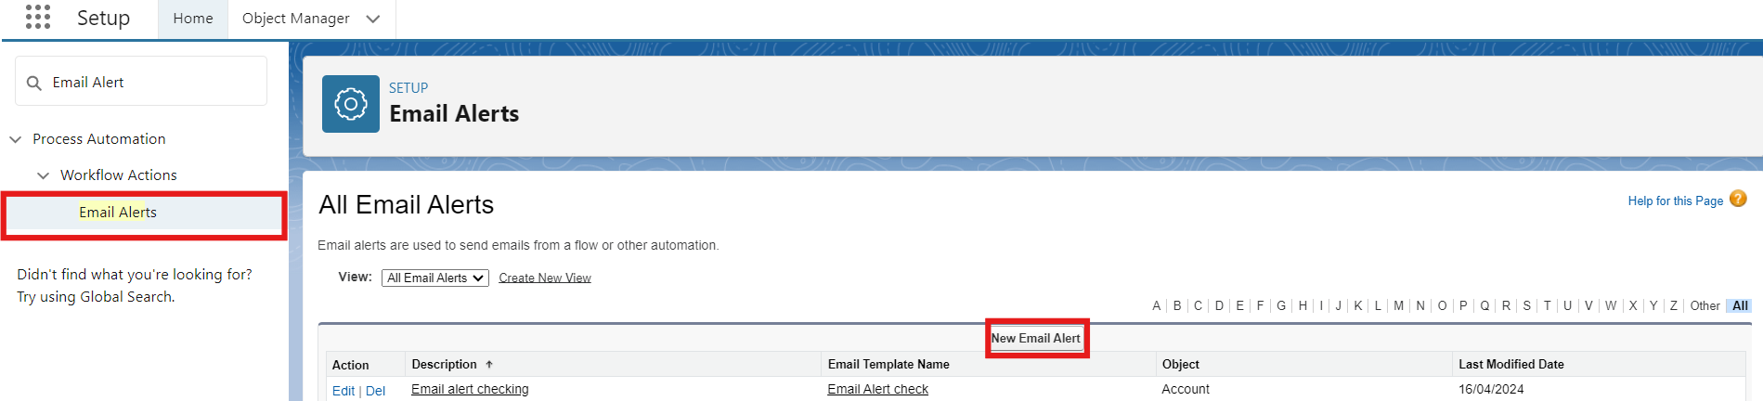

- Click on New Email Alert.

- Description : Happy Birthday email alert
Unique Name : Auto Populates
Object : Customer Account
Email Template : Search for Birthday Offer Email
Recipient Type : Search : Email field : Email ID
From Email Address : Default Workflow user’s email address
Click Save.

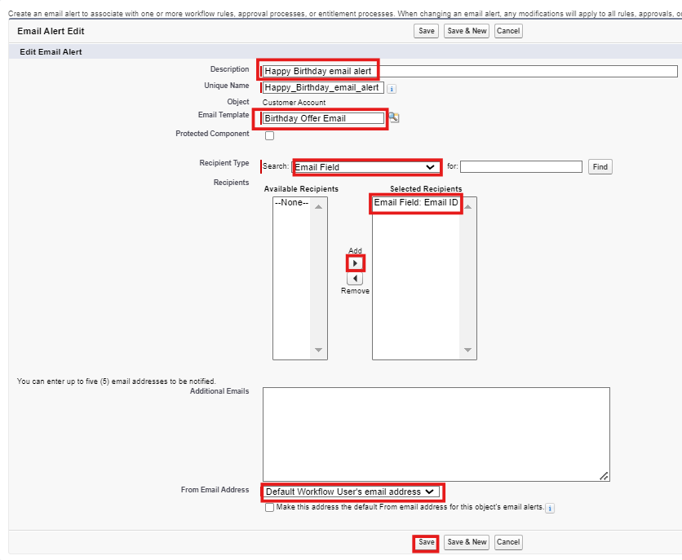

17.Flows

Activity 1: Schedule Triggered Flow

- Go to setup, Type Flow in quick find box → Click on the Flow and Select the New Flow.

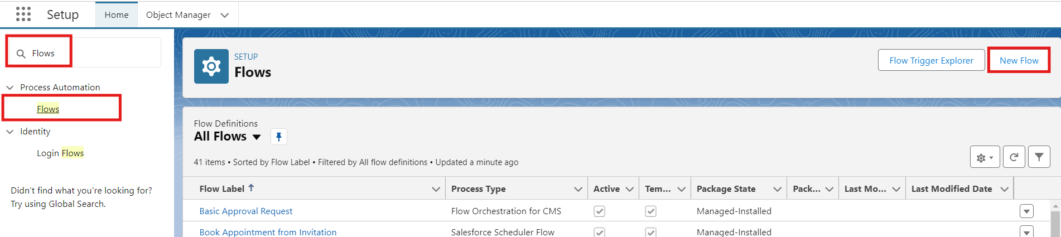

- Select Schedule - Triggered Flow and click Create.
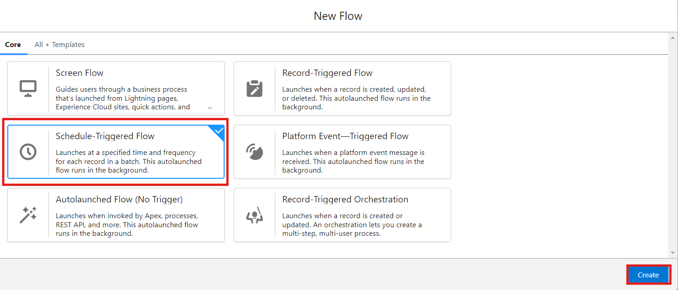

- Set a Schedule
Start Date : Enter the Date, when you want to start the flow.
Start Time : Enter the Time, when you want to start the flow.
Frequency : Daily

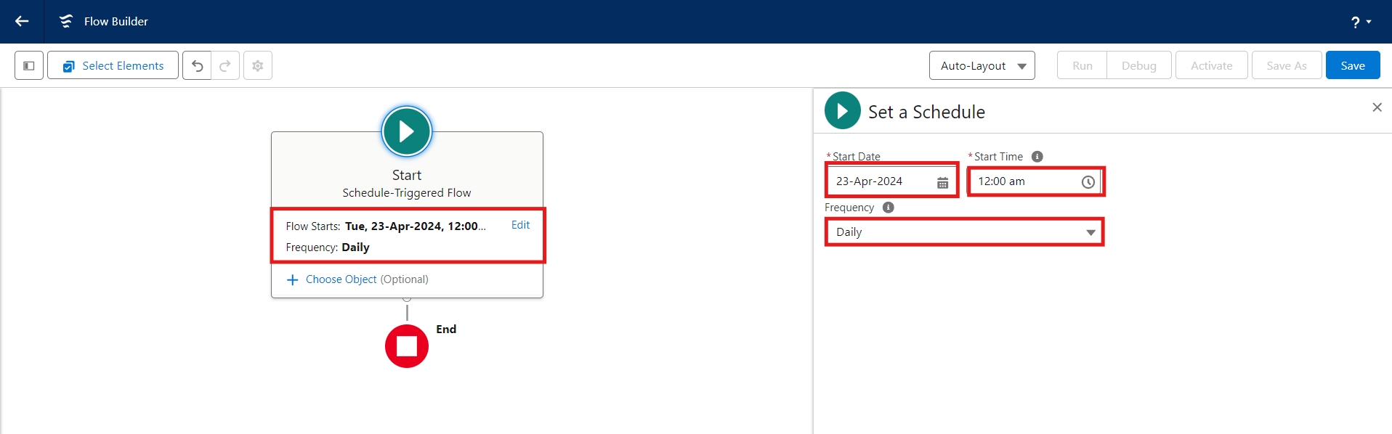

- Create Object
Object : Customer Account
Condition Requirements : All conditions Are Met (AND)
- Field : Date_of_Birthday_is_today__c
Operator : Equals
Value : $GlobalConstant.True
- Field : Email_ID_c
Operator : IS NULL
Value : $GlobalConstant.False

- Click (+) Icon on the flow builder and Select Action Component.

- In New Action Page
Filter By : Type and select Email Alert
In Action : Search and select Happy Birthday email alert
Label : Send Happy Birthday Email
API Name : Auto Populates
Set Input Values for the Selected Action : Record ID : {!$Record.Id}

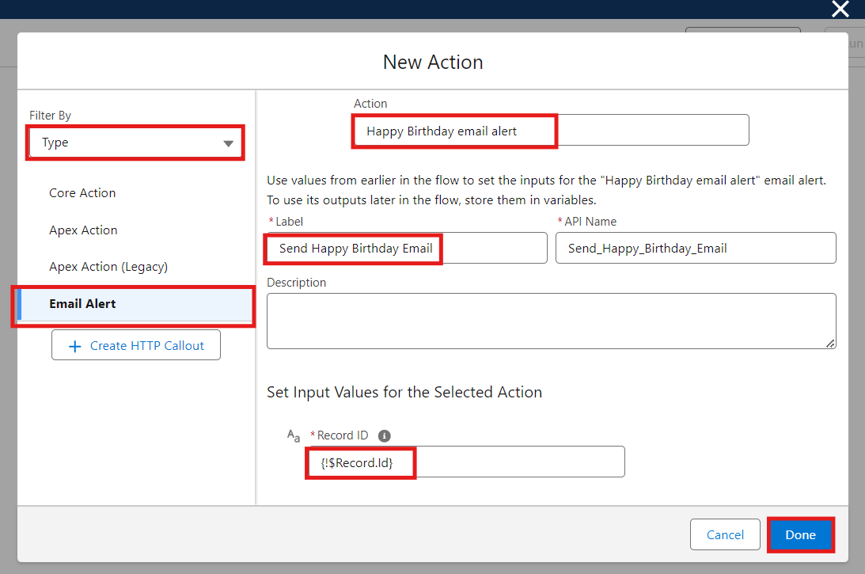

- Click Done.

- Click Save on the top right
Flow Label : Happy Birthday Email Flow
Flow API Name : Auto Populates
Click Save.
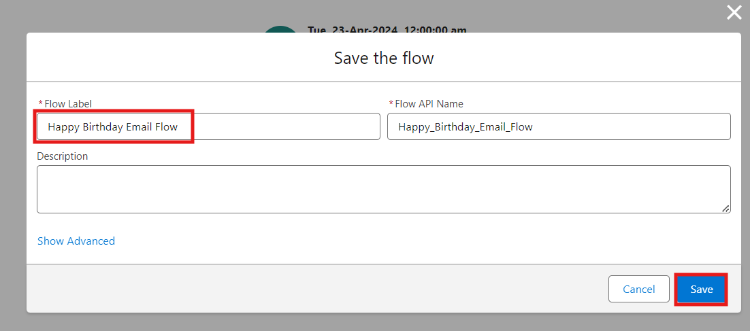

- Click Activate.

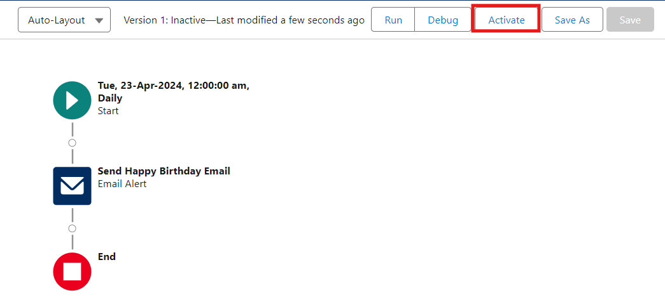

18.Reports & Dashboards

Activity 1: Customer Account Sales Report
- Click App Launcher  and select TheChaiShop&Co.
- Click Reports
- Click New Report

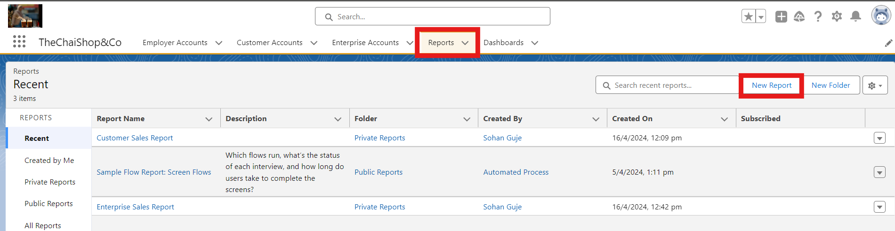

- In search type Customer Accounts and Select Customer Accounts.
- Click Start Report.

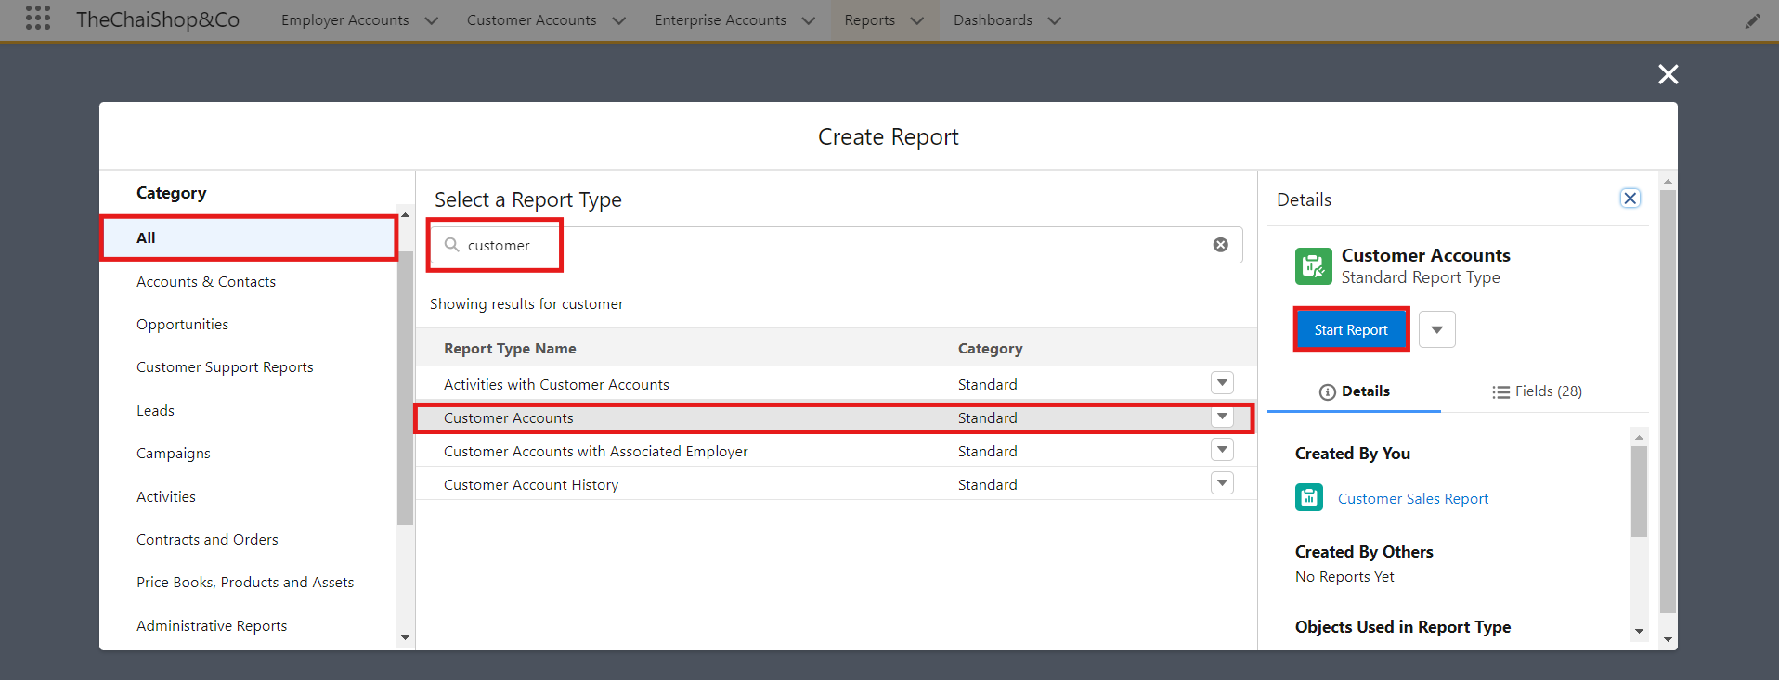

- Click the toggle Update Preview Automatically to ON.
- Drag and Drop all the required Columns from the Outline pane.
- Group Rows : Search and Select
Customer Account: Record Type
- Click Add Chart on the top.

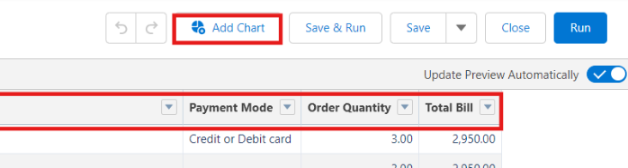

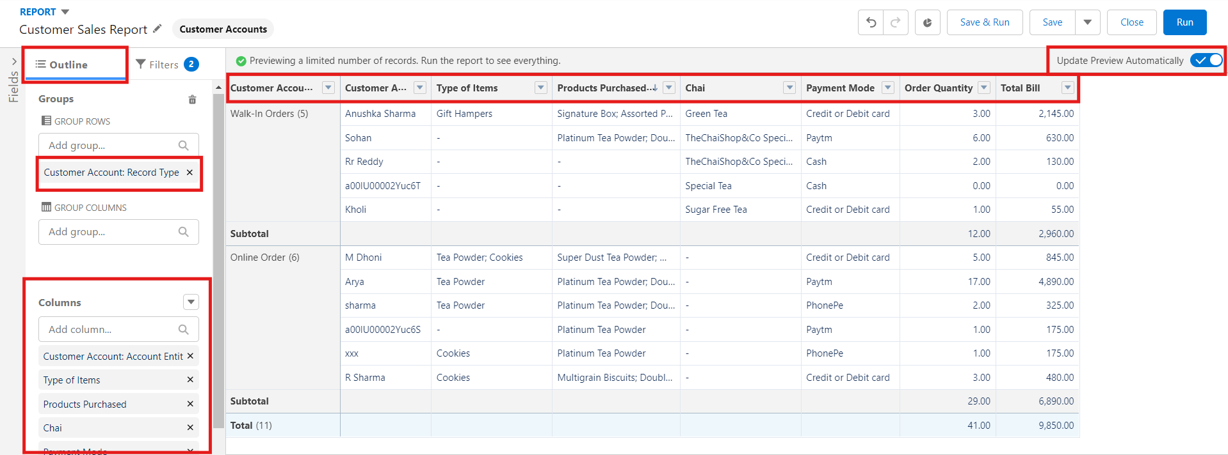

- Click Save on the top right.
Enter
Report Name: Customer Account Sales Report
Report Unique Name : Auto Populates
Click Save.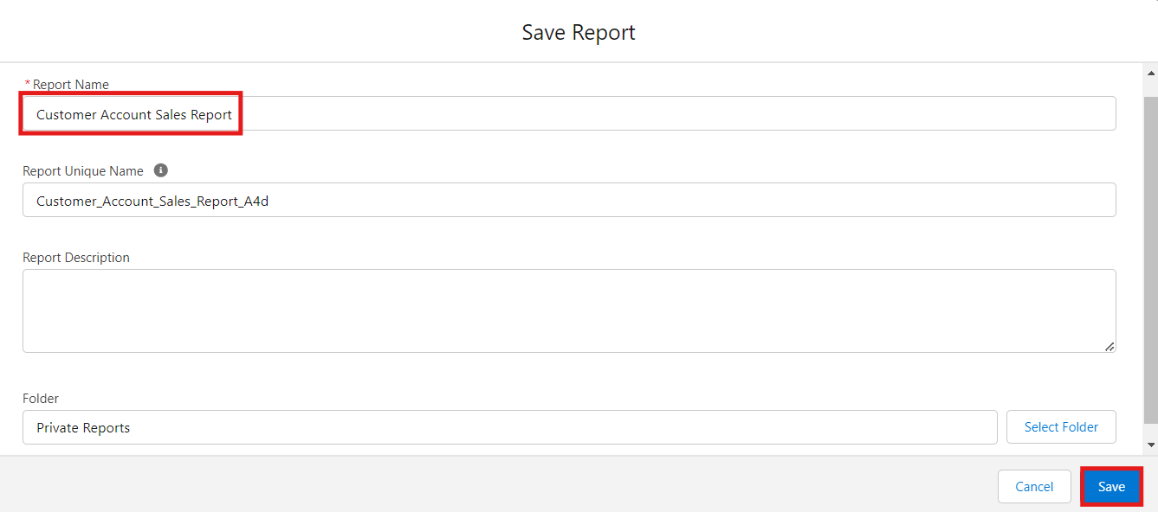

Activity 2: Enterprise Account Sales Report
- Repeat the same steps to create another report.
- Click Reports
- Click New Report
- In search type Enterprise Accounts and Select Enterprise Accounts.
- Click Start Report.
- Click the toggle Update Preview Automatically to ON.
Drag and Drop all the required Columns from the Outline pane.
Group Rows : Search and Select
Type of Items.
- Click Add Chart on the top.

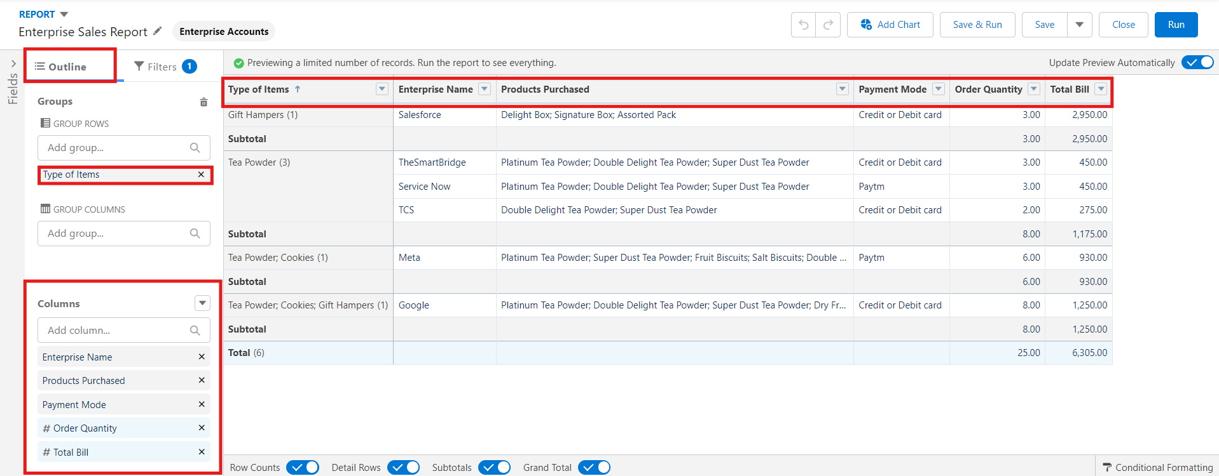

- Click Save on the top right.
  - Enter
  - Report Name : Enterprise Account Sales Report
  - Report Unique Name : Auto Populates
  - Click Save.

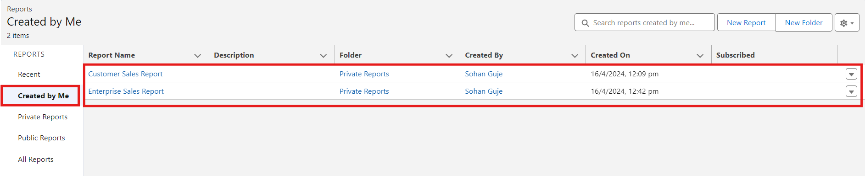

Activity 3: Dashboard

- Click Dashboards
- Click New Dashboards

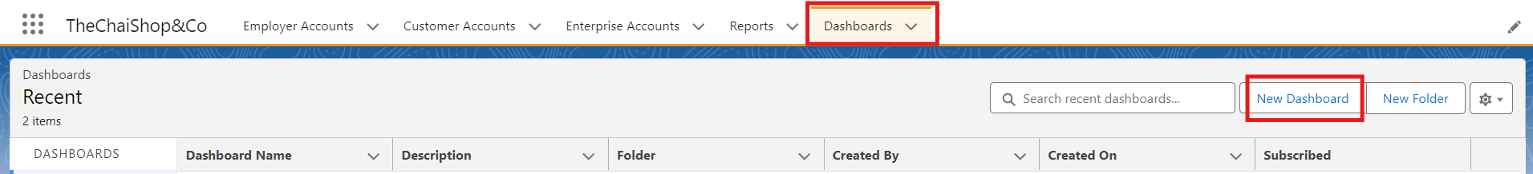

- Name : Customer Vs Enterprise Sales
- Click Create.
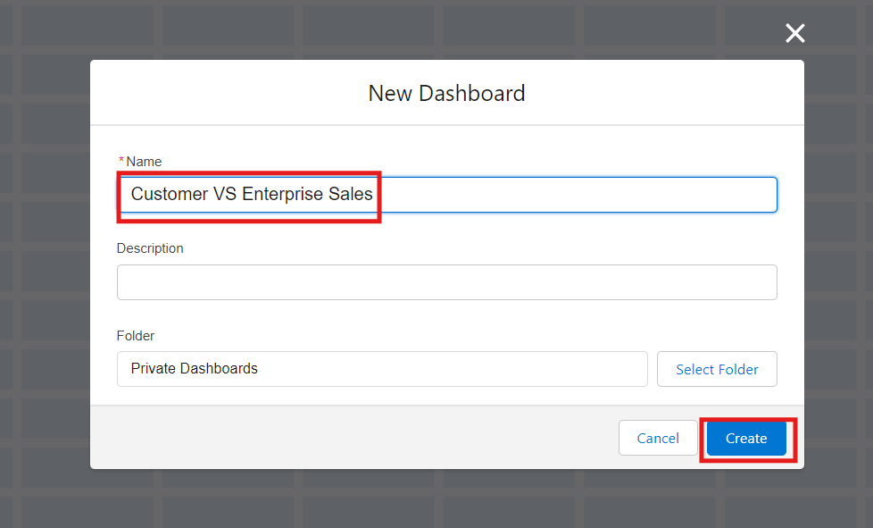
- Click Widget
- Select Chart or Table.

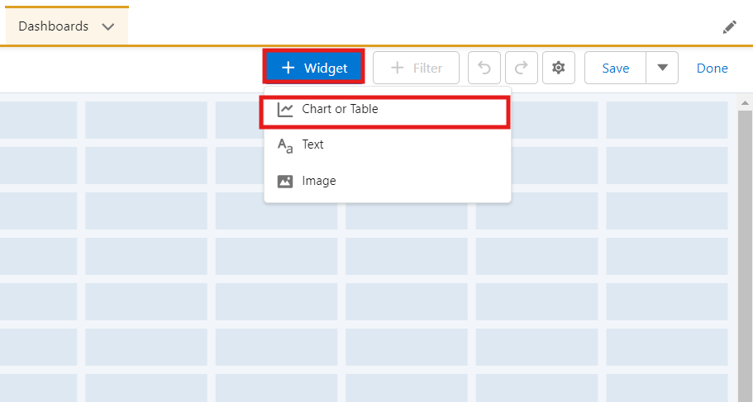

- Select Customer Account Sales Report

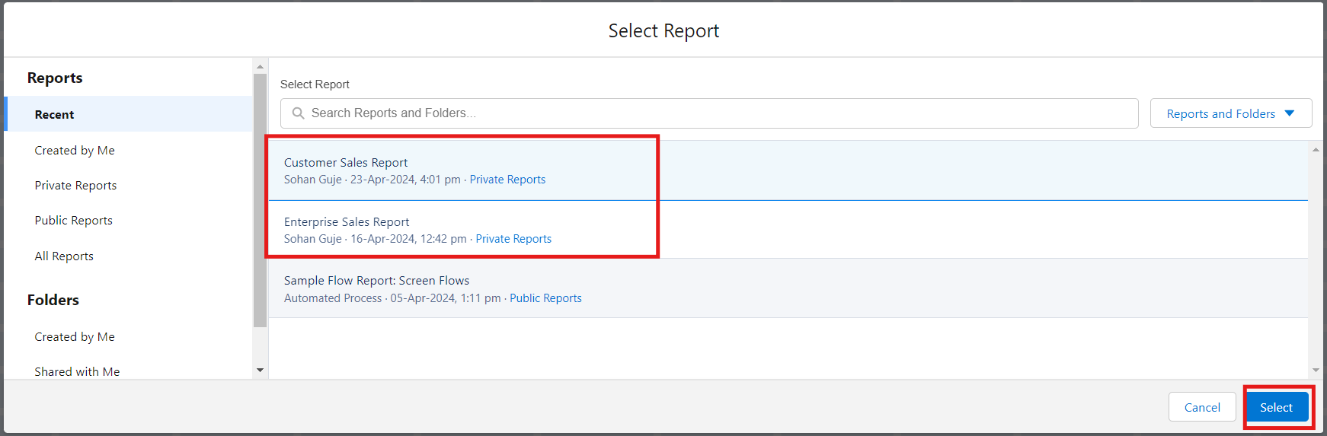

- Display As: Select the one which you feel comfortable with.
- Click Add.
- Repeat the same steps for the Enterprise Account Sales Report.
- Click Save.

19. FUNCTIONAL & PERFORMANCE TESTING

During the testing phase, screenshots were captured from the Salesforce Lightning interface to verify correct system behavior. These include:
- Record creation for Employer, Customer, and Enterprise objects
- Validation rule testing for Aadhar, PAN, and phone numbers
- Verification of record types and page layouts
- Formula field validation for order quantity and billing
- Flow execution for birthday email alerts
- Report and dashboard generation
Performance testing ensured fast response time and system stability during concurrent usage.

20. ADVANTAGES & DISADVANTAGES

Advantages
- Centralized data management
- Reduced manual work
- Automated calculations
- Improved customer engagement
- Real-time analytics

Disadvantages
- Requires Salesforce license
- Internet dependency
- Limited offline access

21. FUTURE SCOPE
- Mobile CRM integration
- AI-based sales prediction
- WhatsApp/SMS alerts
- Inventory management
- Multi-branch support
- Advanced customer profiling

22.Conclusion

In conclusion, the development of TheChaiShop&Co CRM application marks a significant stride in enhancing the store's operational efficiency and customer relationship management capabilities. Seamlessly integrating employer details, customer information (both online and offline), and enterprise data, this application streamlines business processes and enables informed decision-making. The automation of sales calculations, including order quantity and total bill amount, reduces errors and empowers employees to focus on delivering exceptional service. Moreover, automated email notifications for customers' birthdays foster personalized communication and enhance customer engagement.

Appendix: Quick Implementation Checklist
1. Salesforce Developer Org created and verified
2. Account/customer records created
3. Contact records created
4. Product created
5. Price Book and Product Price configured
6. Order created
7. Order Product added
8. Required fields configured
9. Relationships verified
10. Navigation tabs configured
11. The Chai Shop & Co CRM Lightning App created
12. Validation rules tested
13. Page layouts arranged
14. Flow created/tested/activated where required
15. Profiles and permissions configured
16. Roles/users configured
17. Reports created
18. Dashboard created
19. Functional testing completed
20. Demo screenshots and video prepared

Thank You

